DeepEval & RAGAS — Framework Documentation

Table of Contents
- OVERVIEW
- WHY GENAI EVALUATION MATTERS
- INTRODUCTION TO DEEPEVAL
- INTRODUCTION TO RAGAS
- DEEPEVAL VS RAGAS — WHEN TO USE WHAT
- CORE EVALUATION METRICS (DEEPEVAL AND RAGAS)
- SUPPORT EVALUATION (DEEPEVAL AND RAGAS)
- QUALITY ASSURANCE (DEEPEVAL AND RAGAS)
- DEEPEVAL & RAGAS VS ALTERNATIVE EVALUATION FRAMEWORKS
10. CONCLUSION

1.OVERVIEW
Modern Generative AI applications — whether they power customer support bots, document summarization engines, legal assistants, or financial advisors — require a systematic way to measure quality, reliability, and factual accuracy. Unlike traditional software where correctness is binary (pass/fail), GenAI outputs are probabilistic and contextual, making traditional testing approaches insufficient.
DeepEval and RAGAS are the two leading open-source evaluation frameworks purpose-built to solve this problem. They bring structure, repeatability, and measurability to GenAI quality assurance — enabling teams to ship LLM-powered applications to production with confidence.

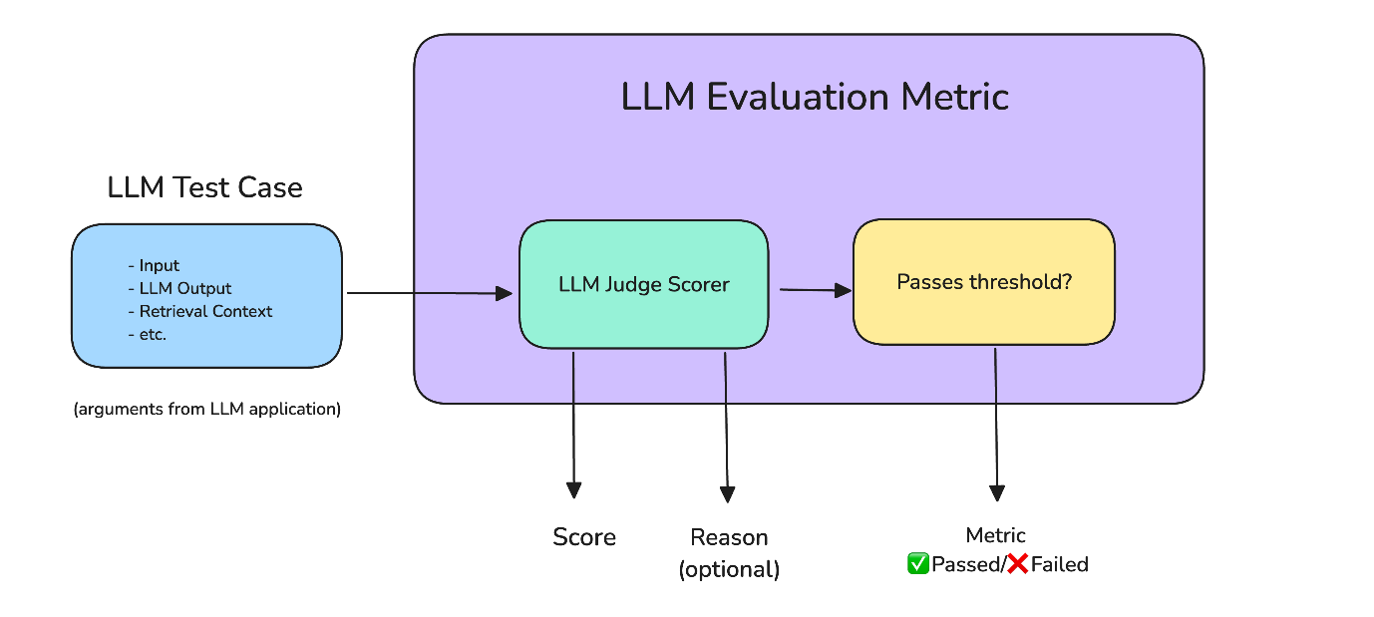
LLM evaluation pipeline architecture diagram

Both frameworks work by defining metrics — quantifiable scores that assess different quality dimensions of LLM responses — and they can run these evaluations programmatically inside CI/CD pipelines, notebooks, or live production systems.

2. WHY GENAI EVALUATION MATTERS
Without proper evaluation, GenAI applications face a set of risks that are unique to language models:

Risk | Description
Hallucination | The model confidently generates factually incorrect information
Context Drift | The model ignores the retrieved context and answers from memory
Prompt Regression | A change to a prompt silently degrades quality across all users
Toxicity & Bias | Outputs that are harmful, biased, or brand-unsafe
Faithfulness Failure | The answer is not grounded in source documents (critical in RAG systems)
Answer Incompleteness | The model provides partial answers missing key facts

Traditional unit tests cannot catch these issues. You need an evaluation framework that understands semantics, context, and language. This is exactly what DeepEval and RAGAS provide.
Comparison: No Evaluation vs. With Evaluation
Feature | Without Evaluation | With Evaluation (CI/CD & Monitoring)
Hallucination Rate | Higher (often 15%–52% in enterprise) | Significantly lower (can drop by 20%–50% via grounding)
Regression Detection | Reactive (found by user complaints) | Proactive (automated alerts on score drops)
User Satisfaction | Declines due to inconsistent quality | Higher consistency and reliability
Risk Mitigation | Minimal; risks persist in high-stakes tasks | High; threshold-based deployment rules

3. INTRODUCTION TO DEEPEVAL
What is DeepEval?
DeepEval is an open-source LLM evaluation framework developed by Confident AI. It is designed to be the "pytest for LLMs" — bringing the familiar developer experience of unit testing directly to language model evaluation.
It allows you to write test cases for your LLM application, define expected behaviors, assign evaluation metrics, and run these tests in your development workflow or CI/CD pipeline.
GitHub: https://github.com/confident-ai/deepeval
Docs: https://docs.confident-ai.com

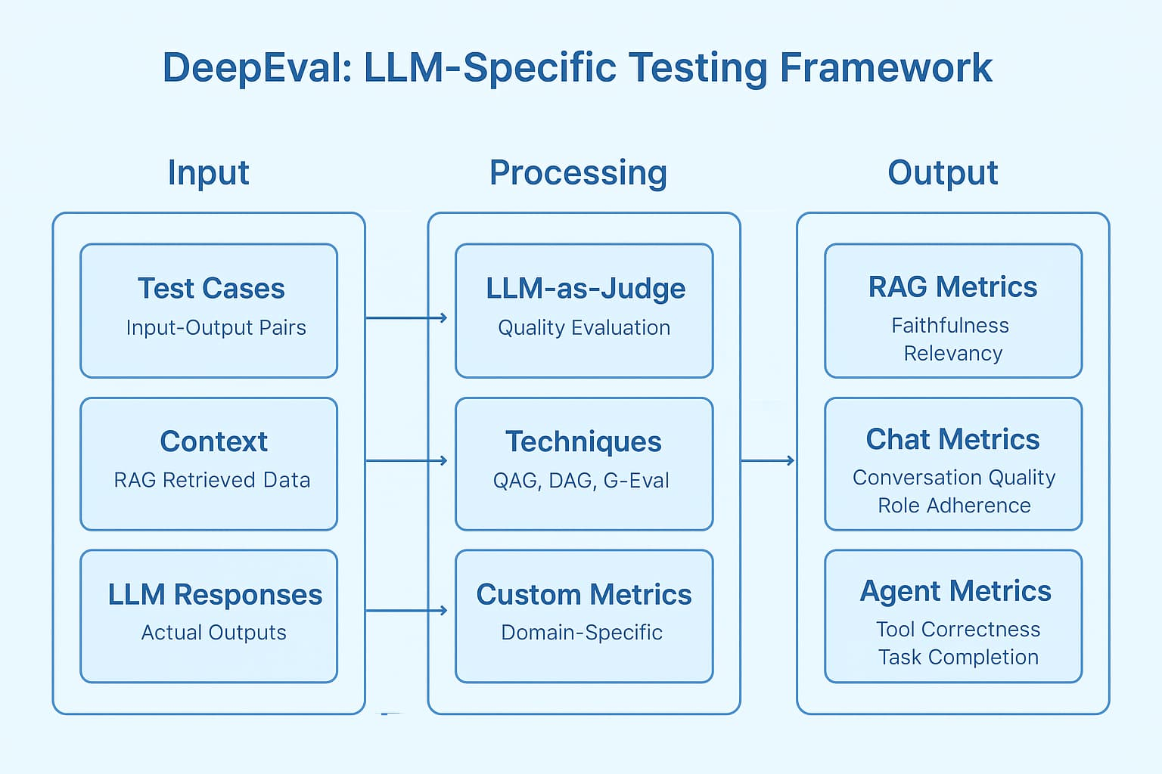
DeepEval confident AI framework overview
Core Philosophy
DeepEval treats every LLM interaction as a testable unit. A test case includes:
- Input — the user's query or prompt
- Actual Output — what the LLM returned
- Expected Output (optional) — the ideal response
- Retrieval Context (for RAG) — the chunks retrieved from the knowledge base

Key Capabilities
- 14+ built-in evaluation metrics (faithfulness, hallucination, answer relevancy, etc.)
- Custom metric creation using LLMs-as-a-judge
- pytest-compatible — integrates directly into existing test suites
- CI/CD integration (GitHub Actions, GitLab CI, Jenkins)
- Dataset management and versioning via Confident AI platform
- Red-teaming capabilities for safety and adversarial testing
- Supports OpenAI, Azure OpenAI, Anthropic, Cohere, local models (Ollama, LM Studio)
- Async evaluation for high-throughput production testing
- Real-time monitoring dashboard (Confident AI cloud)
DeepEval Use Case Coverage
DeepEval is not limited to one type of LLM application. It is built to evaluate across every modern AI interaction pattern — from simple chatbots to complex multi-agent systems.
Use Case | What DeepEval Evaluates | Key Metrics Applied
RAG(Retrieval-Augmented Generation) | Whether retrieved context is used faithfully, retrieval quality, completeness of answer from documents | Faithfulness, Contextual Precision, Contextual Recall, Answer Relevancy
Chatbot/ Conversational AI | Response quality, tone consistency, task completion across multi-turn conversations | Answer Relevancy, Toxicity, Conversation Completeness, Conversation Relevancy
AI Agents | Tool call accuracy, step-by-step reasoning quality, whether the agent completed the task correctly | Tool Correctness, Task Completion, Hallucination per step
MCP(Model Context Protocol) | Whether the model correctly interprets and executes tool/resource calls, context fidelity across protocol steps | Tool Call Accuracy, Context Faithfulness, G-Eval custom criteria
Summarization | Factual accuracy vs source, completeness of key points, no hallucinated additions | Summarization Score, Hallucination, Answer Relevancy
Text-to-SQL/ Code Generation | Correctness of generated SQL/code output against expected logic | G-Eval (custom), Answer Correctness

Synthetic Data Generation
One of the most significant challenges in LLM evaluation is building a high-quality test dataset. Manually writing hundreds of test questions with verified answers is time-consuming and expensive. DeepEval solves this with automated synthetic dataset generation — it reads your source documents and generates realistic test cases automatically.
How It Works
DeepEval's synthesizer takes your knowledge base (PDFs, text files, web pages, vectors) and generates diverse question-context-answer triples that reflect real user behavior. It covers multiple complexity levels — from simple factual questions to multi-hop reasoning queries.
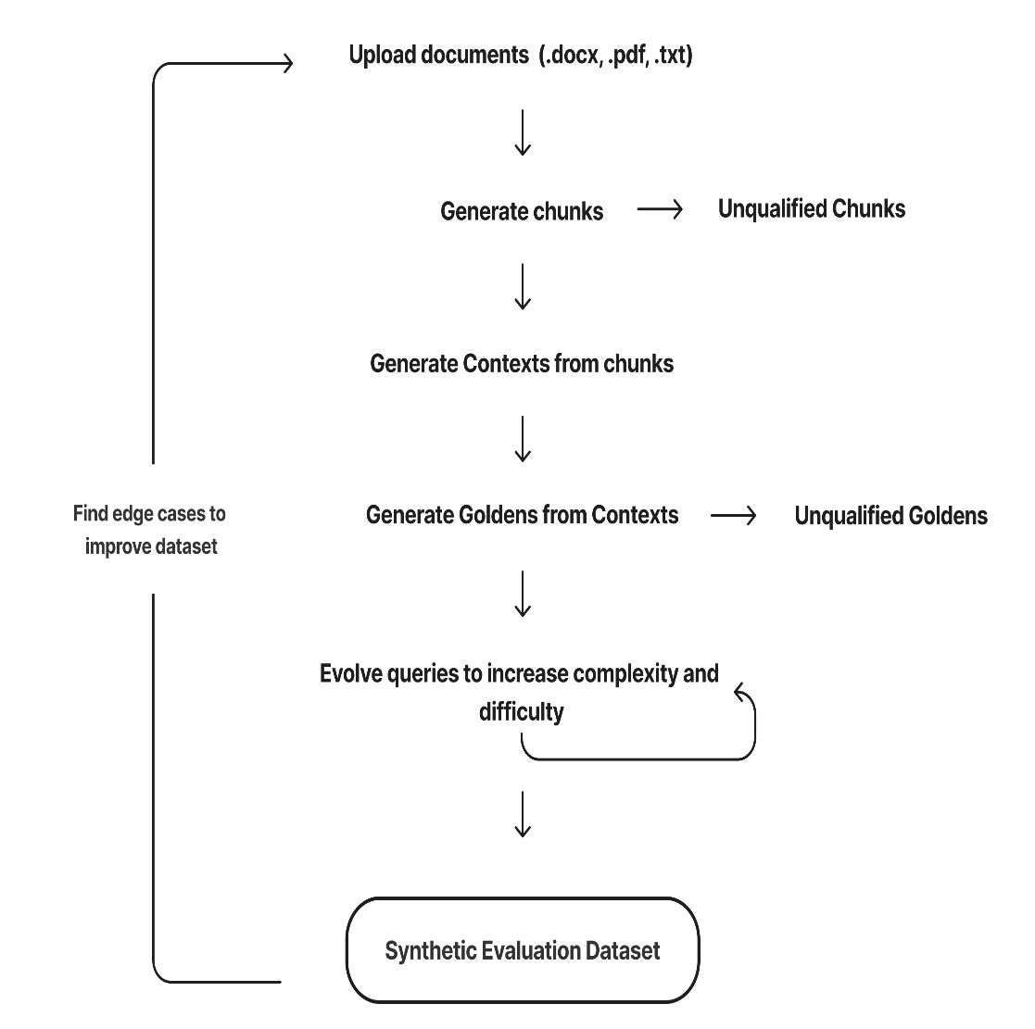
Generate Synthetic Test Data for LLM Applications

LLM Evals — Two Modes of Evaluation
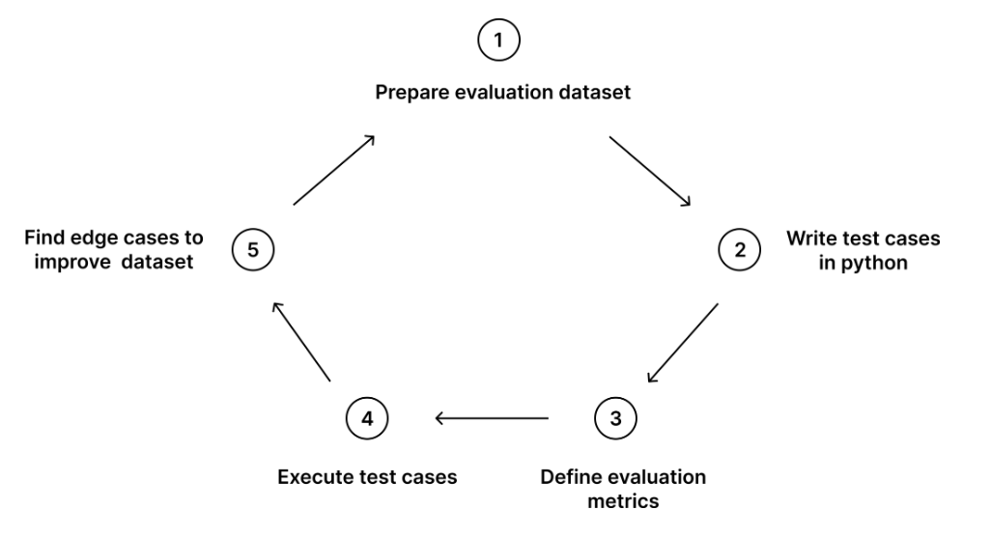
Evaluation Workflow
Mode 1 — End-to-End Evaluation
End-to-end evaluation treats your entire LLM system as a black box. It looks only at what goes in — the user's input — and what comes out — the final response. It does not inspect what happens in between.
When to use End-to-End Evaluation:
- Measuring overall user experience quality
- Regression testing after prompt or model changes
- CI/CD quality gates before production deployment
- Comparing two different LLM systems or providers against each other

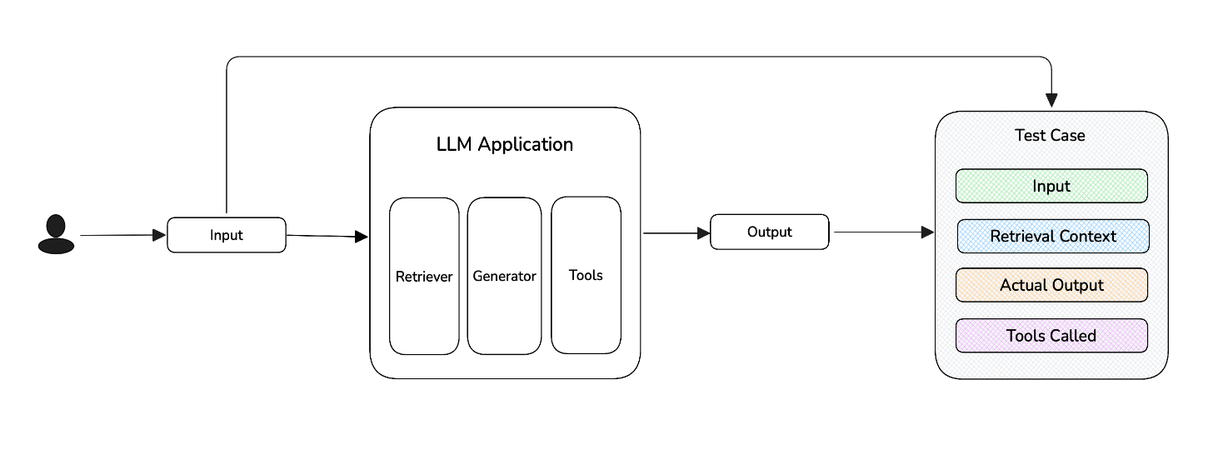

Mode 2 Component-Level Evaluation:
Component-level evaluation opens the black box and evaluates each individual step inside your LLM system separately. For a RAG pipeline, this means evaluating the retriever independently from the generator. For an agent, this means evaluating each tool call and reasoning step on its own.
When to use Component-Level Evaluation:
- Diagnosing why end-to-end scores dropped — isolating retriever vs generator failure
- Optimizing individual components (chunk size, embedding model, top-k retrieval)
- Evaluating agent tool call accuracy step by step
- Fine-tuning decisions — understanding whether the retrieval or generation needs improvement
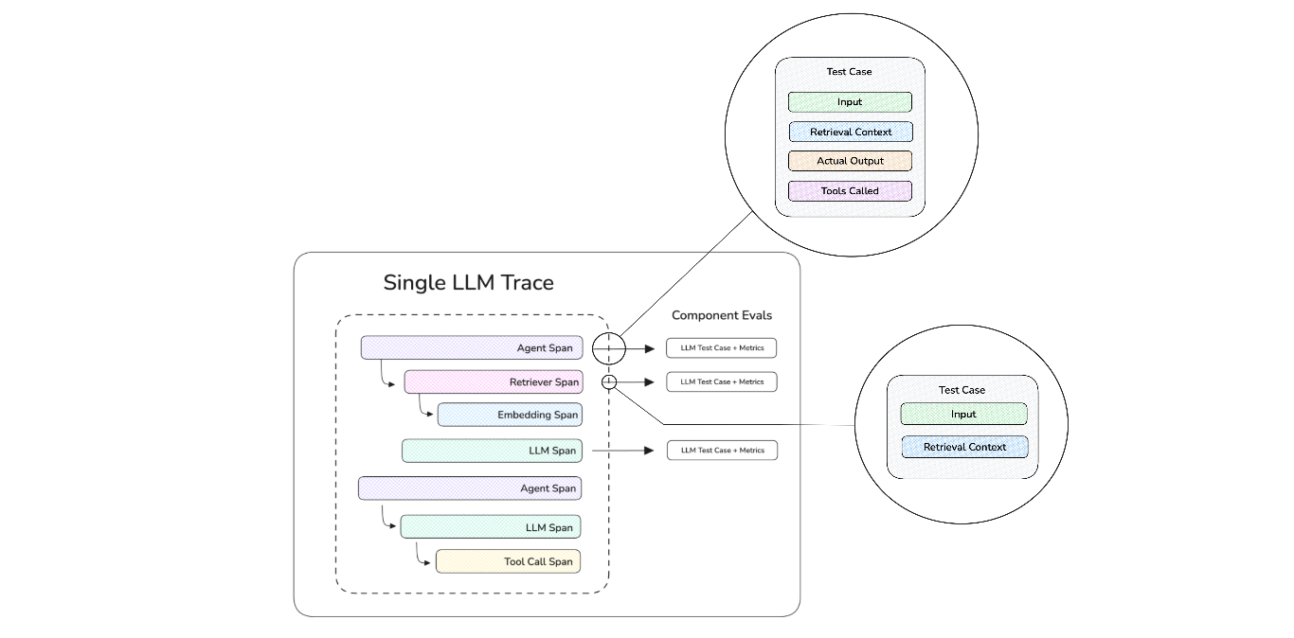

4. INTRODUCTION TO RAGAS
What is RAGAS?
RAGAS (Retrieval Augmented Generation Assessment) is an open-source evaluation framework developed specifically to evaluate RAG (Retrieval-Augmented Generation) pipelines. It was introduced by Exploding Gradients and focuses on measuring the quality of each individual component in a RAG system — the retriever, the generator, and their interaction.
GitHub: https://github.com/explodinggradients/ragas
Docs: https://docs.ragas.io
Core Philosophy
RAGAS evaluates the entire RAG pipeline end-to-end, not just the final output. It asks three foundational questions:
- Did the retriever find the right context?
- Did the generator use the context faithfully?
- Is the final answer complete and relevant to the question?
This decomposition is what makes RAGAS uniquely powerful for document-grounded AI systems.
Key Capabilities
- RAG-specific metrics (faithfulness, context precision, context recall, answer relevancy)
- Reference-free evaluation — does not always require ground truth answers
- Works with LangChain, LlamaIndex, Haystack, and custom RAG pipelines
- Dataset generation from documents (synthetic test set creation)
- Supports OpenAI, Azure OpenAI, HuggingFace, Bedrock, Vertex AI
- Integration with Arize AI, LangSmith, and MLflow for monitoring
- Batch evaluation via pandas DataFrames
- Multi-turn conversation evaluation support

5. DEEPEVAL VS RAGAS — WHEN TO USE WHAT

Understanding the distinction helps you decide how to architect your evaluation strategy.

Dimension | DeepEval | RAGAS
Primary Focus | General LLM application testing | RAG pipeline evaluation
Test Paradigm | Unit test style (pytest) | Dataset batch evaluation
RAG Support | Yes (RAG-specific metrics available) | Yes (primary use case)
Non-RAG Support | Strong (chatbots, summarizers, agents) | Limited
Custom Metrics | LLM-as-judge custom metrics | Custom metric support
CI/CD Integration | Native pytest integration | Requires custom setup
Synthetic Data Gen | Via Confident AI | Built-in testset generator
Safety / Red Teaming | Built-in | Not primary scope
Reference-Free Eval | Supported | Core strength
Best For | End-to-end LLM app quality gates | RAG retrieval + generation quality

Production Recommendation for GenAI Application: Use both in a layered approach — RAGAS for deep RAG pipeline diagnostics and DeepEval for broader quality gates, regression testing, and CI/CD enforcement.

Comparison
Feature | DeepEval | RAGAS
Core Focus | End-to-end unit testing (CI/CD) | Component-level RAG metrics
Workflow | Pipeline-oriented; includes caching & error handling | Component-oriented; reference-free scoring
Metric Type | Self-explaining, debuggable LLM-judges | Formula-based (nli, embedding similarity)
Best For | Production-ready LLM stacks & agentic workflows | Quick, lightweight RAG experimentation

DeepEval: Pipeline Flow Approach
DeepEval treats evaluation like software unit testing. Its flow integrates directly into development cycles:
- Pipeline Focus: It assesses the entire RAG pipeline (Retrieval + Generation) as a single unit or separate components.
- Actionable Debugging: Every metric provides a "reason" generated by an LLM-judge, helping you understand why a score is low rather than just providing a number.
- Platform: Integrates natively with Confident AI for reporting and test management.

RAGAS: RAG Components Approach
RAGAS is designed to isolate the performance of different parts of a RAG system:
- Component-Level Metrics: Specifically measures Faithfulness (generator) and Context Precision/Recall (retriever).
- Reference-Free: It does not require human-annotated ground truth, using other LLMs to judge metrics.
- Data Science Approach: Often used like a library (e.g., pandas) for quick analysis of retrieved information quality.

Recommendation of uses in both
- Use RAGAS if: You need a quick, research-backed way to evaluate the retrieval quality of your RAG pipeline without complex setup.
- Use DeepEval if: You are building a production-grade application and need a framework that supports CI/CD, custom agent testing, and verbose debugging. Many teams use both, applying RAGAS for initial research and DeepEval for ongoing testing.

6. CORE EVALUATION METRICS (DEEPEVAL AND RAGAS)

DeepEval Metrics
In DeepEval, a threshold defines the minimum passing score (0 to 1) for a metric, defaulting to 0.5 for most metrics.
Quick Summary
- Default Threshold: 0.5.
- Passing Criteria: A test passes if the metric score is threshold.
- Strict Mode: If strict_mode=True, the threshold is automatically overridden to 1.0 (requiring perfection).
Detailed Context
DeepEval uses these thresholds to determine if an LLM's output meets your quality standards. You can customize this value when initializing any metric.
Metric Configuration Table (Common Parameters):
Parameter | Default | Description
Threshold | 0.5 | Minimum score required to pass (0.0 to 1.0).
Strict Mode | False | When True, overrides threshold to 1.0; only 1s pass.
Include Reason | True | Whether to provide an explanation for the score.

1.Answer Relevancy Measures whether the LLM's response is actually relevant to the user's question. A response that talks around the topic without addressing the core query will score low.
2.Faithfulness For RAG applications — measures if every claim in the generated answer is supported by the retrieved context. Detects hallucinations within the grounded context.
3.Hallucination Detects factual inaccuracies by comparing the output to provided context. Crucial for high-stakes domains like legal, medical, and financial.
4.Contextual Precision & Recall
- Precision — Are the retrieved chunks relevant to the question?
- Recall — Did the retriever find all the necessary chunks to answer the question?
5.Toxicity Scores how toxic, harmful, or unsafe the response is. Essential for public-facing consumer applications.
6.G-Eval (Custom LLM-as-Judge) Allows you to define your own evaluation criteria in natural language. The evaluator LLM becomes the judge.
RAGAS Metrics
Faithfulness The fraction of claims in the generated answer that are supported by the retrieved context. Score range: 0–1.
Faithfulness = Supported Claims / Total Claims in Answer
Answer Relevancy Measures how pertinent the generated answer is to the given question. Uses reverse question generation — the evaluator generates questions from the answer and checks if they match the original.
Answer Relevancy = avg(cosine_similarity(generated_questions, original_question))
Context Precision Measures whether the highly relevant chunks are ranked at the top of the retrieved context. Rewards retrievers that prioritize the most useful documents.
Context Precision = Σ(Precision@k × relevance_k) / Total Relevant Items
Context Recall Checks if all the information needed to answer the question is present in the retrieved context. Requires ground truth answers.
Context Recall = Attributable Sentences / Total Sentences in Ground Truth
Answer Correctness (requires ground truth) Combined metric evaluating factual correctness and semantic similarity between the generated answer and the reference answer.
Context Entity Recall Measures how many entities present in the ground truth are captured in the retrieved context. Useful for entity-heavy domains like finance and healthcare.
Metrics Based Workflow to Choose:
DeepEval and Ragas both specialize in RAG evaluation, however:
- Ragas's metrics has limited support for explanability, verbose log debugging, and error handling, and customizations
- DeepEval's metrics go beyond RAG, with support for agentic workflows, LLM chatbot conversations, all through its plug-and-play metrics.

7. SUPPORT EVALUATION (DEEPEVAL AND RAGAS)
Evaluation is not a pre-launch checklist — it is a continuous quality signal that runs across the entire lifetime of a GenAI application. DeepEval and RAGAS provide the infrastructure to make that signal measurable, consistent, and actionable.
What Evaluation Measures
Every GenAI interaction must be assessed across four dimensions. Missing any one of them creates a blind spot in your quality coverage.
Evaluation Dimension | The Question Being Answered | Failure Looks Like
Retrieval Quality | Did the system fetch the right information? | Correct-sounding answer built on wrong source documents
Generation Faithfulness | Did the LLM use the retrieved context accurately? | Fluent answer that contradicts or ignores the source
Answer Relevancy | Does the response actually address the user's question? | On-topic but incomplete or misaligned response
Safety & Appropriateness | Is the response free from harm, bias, or scope violations? | Technically correct answer that is toxic or non-compliant

Where Evaluation Runs in the Application Lifecycle
Stage | When It Runs | What Is Evaluated | Tool Used
Development | Every prompt or code change | Test cases against golden dataset | DeepEval
Pre-Release | Before every deployment | Full pipeline regression vs baseline | DeepEval + RAGAS
Production | Nightly on sampled live traffic | Real user interactions (anonymized) | RAGAS + DeepEval

How DeepEval and RAGAS Split Evaluation Responsibility
Both tools are complementary. Using only one gives you a partial picture.
Responsibility | DeepEval | RAGAS
End-to-end response quality | Primary | Partial
Retriever component scoring | Available | Primary
Generator faithfulness | Yes | Yes
Prompt regression detection | Yes | Manual setup
Safety & red-teaming | Built-in | Not in scope
Synthetic test data generation | Yes | Yes
CI/CD pipeline integration | Native pytest | Script-based
Production batch monitoring | Yes | Yes

Evaluation Coverage by Application Type
Application Type | Must Evaluate | DeepEval Metric | RAGAS Metric
RAG Assistant | Retrieval accuracy + generation grounding | Faithfulness, Hallucination | Context Precision, Context Recall
Chatbot | Response relevance + safety | Answer Relevancy, Toxicity | Answer Relevancy
AI Agent | Tool call accuracy + task completion | Tool Correctness, Task Completion | —
Summarizer | Factual accuracy vs source | Summarization, Hallucination | Faithfulness
Text-to-SQL | Query correctness | G-Eval (custom) | —
Multi-turn Conversation | Consistency across turns | Conversation Completeness | —

8.QUALITY ASSURANCE (DEEPEVAL AND RAGAS)
Quality assurance in GenAI is not about catching crashes or syntax errors — it is about detecting silent failures: outputs that are fluent, well-formatted, and confidently wrong. DeepEval and RAGAS together form the QA backbone that makes production GenAI applications measurable, enforceable, and trustworthy at every stage.
The Core Problem QA Must Solve
 | Traditional Software Failure | GenAI Silent Failure
Visible in logs | Yes — error thrown | No — clean 200 response
Detectable by monitoring | Yes — uptime/error rate alerts | No — system appears healthy
Impact on user | Immediate and obvious | Delayed — user acts on wrong information
Detection method | Standard APM tools (Datadog, New Relic) | Semantic evaluation framework
Solved by | Traditional QA | DeepEval + RAGAS

How DeepEval and RAGAS Cover the Full QA Surface
QA Responsibility | DeepEval | RAGAS
End-to-end response quality | Primary strength | Partial
Retriever quality (Precision/Recall) | Available | Primary strength
Generator faithfulness | Yes | Yes
Hallucination detection | Yes | Indirect via faithfulness
Answer relevancy | Yes | Yes
Safety & toxicity | Built-in | Not in scope
Red-teaming & adversarial | Built-in engine | Not in scope
Prompt regression detection | Native pytest CI/CD | Requires custom setup
Synthetic test data generation | Synthesizer included | Testset generator included
Production batch monitoring | Yes | Yes
Component-level RAG diagnostics | Yes | Primary strength

Quality Gates — Four Enforcement Checkpoints
A quality gate is a defined checkpoint where the application must meet its metric thresholds before progressing to the next stage. DeepEval and RAGAS are mapped to specific gates based on their strengths.
Gate | Triggered By | Primary Tool | What Is Evaluated | On Failure
Gate 1 — Development | Every prompt or code change | DeepEval | Single component vs curated test cases | Developer is notified, local fix required
Gate 2 — Integration | Pull request to main branch | DeepEval + RAGAS | Full pipeline regression vs baseline scores | PR merge is blocked automatically
Gate 3 — Pre-Production | Before deployment to production | DeepEval (red-team included) | Complete suite + safety + adversarial checks | Deployment is blocked, escalation raised
Gate 4 — Production | Nightly scheduled batch | RAGAS + DeepEval | Sampled live traffic (2–5% anonymized) | Alert triggered, human review queue populated

Retrieval QA vs Generation QA
The most actionable feature of using RAGAS and DeepEval together is the ability to separate retrieval failures from generation failures. This turns a vague quality complaint into a precise, directed engineering fix.
 | Retrieval QA | Generation QA
What it measures | Whether the right documents were fetched | Whether the LLM used those documents correctly
Primary tool | RAGAS | DeepEval
Key metrics | Context Precision, Context Recall | Faithfulness, Hallucination
Failure cause | Bad chunking, wrong embedding model, missing documents | Weak prompt, context window overflow, conflicting chunks
Fix direction | Indexing pipeline, chunk strategy, embedding model | Prompt engineering, context formatting, model selection

Quality Regression — Detecting When Good Becomes Bad
Regression is when a change that appears unrelated to quality silently degrades metric scores between versions. It is the most common and most missed QA failure mode in production GenAI systems.
Most common regression triggers and which tool detects them:
Change Made | Metric Degraded | Detected By | Cause
System prompt shortened | Faithfulness ↓ | DeepEval | Model fills gaps from training memory instead of context
New documents added to knowledge base | Context Precision ↓ | RAGAS | Overlapping content introduces retrieval noise
LLM model version upgraded by provider | Any metric ↓ | Both | Subtle generation behavior shift without notice
Chunk size increased | Context Recall ↓ | RAGAS | Fewer, larger chunks miss specific details
Embedding model changed | Context Precision ↓ | RAGAS | Semantic space mismatch with existing vector index
Top-k retrieval count reduced | Context Recall ↓ | RAGAS | Fewer documents fetched, necessary content missed

9.DEEPEVAL & RAGAS VS ALTERNATIVE EVALUATION FRAMEWORKS
Frameworks Cover with alternative frameworks
Framework | Type | Open Source | Primary Purpose
DeepEval | LLM Evaluation | Yes | Production LLM testing & QA
RAGAS | RAG Evaluation | Yes | RAG pipeline diagnostics
TruLens | LLM Evaluation | Yes | RAG + LLM feedback scoring
LangSmith | Observability | Partial | LLM tracing + basic evaluation
MLflow LLM Eval | Experiment Tracking | Yes | ML experiment management
Promptfoo | Prompt Testing | Yes | Prompt-level testing & red-teaming
Arize Phoenix | Observability | Yes | LLM observability & tracing

Where Each Alternative Is Stronger and Weaker
TruLens - Systematically evaluate and track your LLM experiments
 | Details
Stronger than DeepEval + RAGAS | Local dashboard available instantly with no cloud account needed. RAG Triad (answer relevance, context relevance, groundedness) is visually clear for non-technical stakeholders. Easier first-time setup.
Weaker than DeepEval + RAGAS | No native CI/CD integration — quality gates need manual scripting. No red-teaming or safety evaluation. No synthetic test data generation. Smaller metric library. Fewer active community contributions and slower release cadence.
Production Verdict | Suitable for development-phase RAG debugging. Not sufficient as a standalone production QA framework.

Arize Phoenix - ML observability, monitoring, & tracing
Dimension | Arize Phoenix vs DeepEval + RAGAS
Where Arize Phoenix is stronger | Best open-source option for production LLM observability — embedding visualizations, cluster analysis of user query patterns, and drift detection are uniquely strong. Excellent for understanding how real user query distributions evolve over time. Local deployment with no cloud dependency.
Where Arize Phoenix is weaker | Evaluation metrics are basic compared to DeepEval — limited to hallucination and QA correctness. No red-teaming, no synthetic data generation, no RAG-specific depth of RAGAS. Primarily an observability tool that surfaces where to look, not a QA tool that enforces quality standards.
Best fit | Teams needing visual observability and embedding-level analysis of production traffic. Best combined with DeepEval and RAGAS as the observability layer while the two primary frameworks handle evaluation scoring.

MLflow LLM Evaluation – Evaluation and Monitoring
 | Details
Stronger than DeepEval + RAGAS | Best-in-class experiment versioning and run comparison. Ideal for tracking evaluation scores across model versions, prompt versions, and dataset versions in one unified interface. Deep enterprise integration with Databricks.
Weaker than DeepEval + RAGAS | LLM metric library is small — faithfulness and answer relevancy are available but lack the depth and breadth of DeepEval's 14+ metrics. No red-teaming, no synthetic data generation, no RAG retrieval diagnostics. Evaluation is a module within a broader platform, not the core product.
Production Verdict | Best used as the metric logging and versioning backend for DeepEval and RAGAS output — not as the primary evaluator.

Promptfoo - focused prompt testing tool
 | Detail
Stronger than DeepEval + RAGAS | Fastest tool for prompt A/B comparison — runs in seconds with zero configuration via CLI. YAML-driven setup is accessible to non-developers. Built-in red-teaming for adversarial prompt testing is genuinely strong and comparable to DeepEval's red-

Full Capability Comparison with other alternative frameworks for Evaluation Core, Safety & Testing, Production & Observability in table:
Evaluation Core:
Capability | Full Support | Partial Support | Not Supported
RAG-specific metrics | DeepEval, RAGAS, TruLens | LangSmith, MLflow, Arize Phoenix | Promptfoo
End-to-end LLM testing | DeepEval, TruLens, MLflow, Promptfoo | RAGAS, LangSmith, Arize Phoenix | —
LLM-as-judge (custom metrics) | DeepEval, RAGAS, TruLens, LangSmith, MLflow | Promptfoo, Arize Phoenix | —
Agent evaluation | DeepEval | TruLens, LangSmith, Promptfoo, Arize Phoenix | RAGAS, MLflow
Synthetic data generation | DeepEval, RAGAS | — | TruLens, LangSmith, MLflow, Promptfoo, Arize Phoenix
Safety & Testing:
Capability | Full Support | Partial Support | Not Supported
Red-teaming & safety testing | DeepEval, Promptfoo | — | RAGAS, TruLens, LangSmith, MLflow, Arize Phoenix
Native CI/CD — pytest integration | DeepEval, Promptfoo | — | RAGAS, TruLens, LangSmith, MLflow, Arize Phoenix
Metric versioning & regression | DeepEval, MLflow | RAGAS, TruLens, LangSmith, Arize Phoenix | Promptfoo
Production & Observability
Capability | Full Support | Partial Support | Not Supported
Production monitoring | DeepEval, RAGAS, TruLens, LangSmith, MLflow, Arize Phoenix | — | Promptfoo
Trace-level observability | LangSmith, Arize Phoenix | DeepEval, TruLens | RAGAS, MLflow, Promptfoo
Local model support | DeepEval, RAGAS, TruLens, MLflow, Promptfoo, Arize Phoenix | LangSmith | —
No-code UI dashboard | TruLens, LangSmith, MLflow, Arize Phoenix | DeepEval | RAGAS, Promptfoo

10.CONCLUSION
DeepEval and RAGAS together answer the most important question in production GenAI development — not just whether your application is running, but whether it is actually working. DeepEval enforces quality at every stage of the development lifecycle, from catching prompt regressions in CI/CD to blocking unsafe deployments before they reach users. RAGAS diagnoses exactly where and why a RAG pipeline is failing, giving teams the precision to fix the right thing fast. Neither tool duplicates the other — they are designed to work as a pair, covering the full evaluation surface that production-grade GenAI applications demand.

